**Responsive Animation with HTML5, CSS3 and the JavaScript Canvas**

**By Rob Robinson**

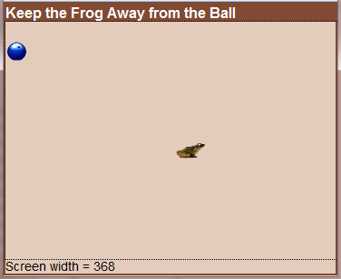**Abstract**

Creating HTML5 games and animated applications that run in any recent browser on any desktop, laptop, tablet or smart phone requires planning and a few special techniques. Topics covered are: Planning the scenes and interactions, designing the layout, detecting the device and window size, sizing the canvas, scaling the graphics, performing animations, responding to keyboard and mouse events on laptops and desktops, responding to touch events on tablets and smart phones, and completing the game with appropriate interactions. A simple “Keep Away” game will be used to demonstrate the techniques.

|  |  |
| --- | --- |
| Presented at [**Twin Cities Code Camp 18**](http://www.eventbrite.com/e/twin-cities-code-camp-18-tickets-15709716184?utm_source=eb_email&utm_medium=email&utm_campaign=email_attendees&utm_term=event) | |
| https://cdn.evbstatic.com/s3-s3/marketing/emails/icon_hostedby_no-trans_bw.gif | Hosted by Twin Cities Code Camp |
| https://cdn.evbstatic.com/s3-s3/marketing/emails/icon_datetime_no-trans_bw.gif | Saturday, April 25, 2015 from 7:30 AM to 3:45 PM (CDT) |
| https://cdn.evbstatic.com/s3-s3/marketing/emails/icon_location_no-trans_bw.gif | University of Minnesota Rapson Hall, 89 Church Street Southeast, Minneapolis, MN 55455 |

Speaking of copies, Feel free to use this code to experiment with and to incorporate the techniques in your own apps. You can download the files from <http://www.learnmorecode.com/ra/files.zip>. The files include all HTML, CSS, JavaScript and images files for the app plus a 12-page tutorial paper and the PowerPoint slides. Please do not post the app, the tutorial or the PowerPoint slides on other Web sites. You may try the app at <http://www.learnmorecode.com/ra/keepAway.html> Questions may be directed to [rrobinson@sf.coloradotech.edu](mailto:rrobinson@sf.coloradotech.edu) or [robrobinson47@gmail.com](mailto:robrobinson47@gmail.com).

Rob Robinson has been teaching software and Web development at Colorado Technical University since 2000. Prior to that he was an IT Director at Northwestern College in Iowa for 17 years, an academic computing specialist at Arizona State University for 3 years, a computer systems designer at Scripps Institute of Oceanography for 3 years, and a senior scientific programmer at Colorado State University for 4 years.